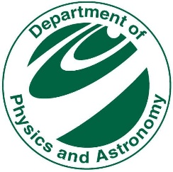
Record of Dissertation & Oral Examination
Department of Physics and Astronomy

Student Name:
Student ID #
Thesis advisor:

- Dissertation title:

- Dissertation has been:
Accepted as is Minor Revisions Major Revisions Rejected
- Oral examination in defense of dissertation was conducted on: ____________________________
The student Passed
Failed Reason:

- What will student do after graduation from Michigan State University:
Postdoctoral Industry Other: ______________________________
- Mailing address after graduation:

Signatures of Guidance Committee Printed Name Date

______________________________________ ______________________________ ___________________
Chairperson of Guidance Committee
______________________________________ ______________________________ ___________________
______________________________________ ______________________________ ___________________
______________________________________ ______________________________ ___________________
______________________________________ ______________________________ ___________________
______________________________________ ______________________________ ___________________
- List major revisions required:

6a- Sign here when all revisions are completed ______________________________________
Chairperson of Guidance Committee

- Graduate Program Director ______________________________________

**Turn into Kim Crosslan, BPS 1312a**

